CELL DOCUMENTATION
CELL 1: Importing Libraries
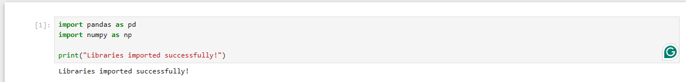

What This Code Does
This cell loads the essential Python tools we need for the entire project. Think of it like gathering your ingredients before cooking.

Tool | What it does | Why we need it
pandas (pd) | Handles tabular data (like Excel spreadsheets) | We use it to read CSV files, clean data, and organize our dataset
numpy (np) | Handles mathematical operations | We use it for calculations behind the scenes

Line-by-Line Breakdown

Line | Explanation
import pandas as pd | Load the pandas library and give it the shorter nickname "pd" so we type less
import numpy as np | Load the numpy library and give it the nickname "np"
print("Libraries imported successfully!") | Prints a confirmation message so we know everything worked

Why This Matters
Without these two libraries, we cannot:

- Read the dataset files (pandas does that)

- Handle missing values (pandas does that)

- Perform mathematical operations (numpy does that)

- Train machine learning models (both are used internally)

Think of it like: You can't bake a cake without flour and eggs. You can't do data science without pandas and numpy.

Practical Application
In this project, we use pandas to:

- Read the .data files from the UCI dataset

- Merge 4 different files into 1 big dataset

- Clean missing values

- Create new columns (like the target column)

We use numpy to:

- Handle mathematical operations when scaling features

- Work with arrays of data

How to Check It Worked
When you run this cell, you should see:

Libraries imported successfully!
If you see this, you're ready to proceed!

If you get an error, it means the libraries aren't installed. Fix with:
pip install pandas numpy

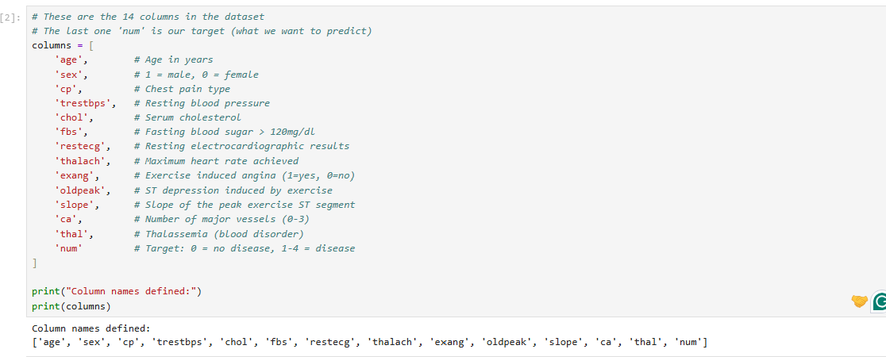
CELL2 : Defining Column Names

What This Code Does
The .data files from UCI do NOT have column names at the top. They are just raw numbers. We need to tell pandas what each column represents so we can understand and work with the data.

Think of it like: You get a spreadsheet with no headers. You have to manually label Column A as "Age", Column B as "Sex", etc.

Line-by-Line Breakdown
Line | Explanation
columns = [ | Creates a list called columns that will hold all the column names
'age', 'sex', ... | Each entry is a column name. The comments (#) explain what each one means
'num' | This is the target column – what we want to predict. 0 = No Disease, 1-4 = Disease
print("Column names defined:") | Prints a header message
print(columns) | Prints the full list of column names so we can see them

The 14 Columns Explained
Column Name | Meaning | Type
age | Patient's age in years | Numeric
sex | Gender (1 = Male, 0 = Female) | Categorical
cp | Chest pain type (1-4) | Categorical
trestbps | Resting blood pressure (mm Hg) | Numeric
chol | Serum cholesterol (mg/dl) | Numeric
fbs | Fasting blood sugar > 120 mg/dl (1=True, 0=False) | Categorical
restecg | Resting ECG results (0, 1, 2) | Categorical
thalach | Maximum heart rate achieved | Numeric
exang | Exercise induced angina (1=Yes, 0=No) | Categorical
oldpeak | ST depression induced by exercise | Numeric
slope | Slope of the peak exercise ST segment | Categorical

Why This Matters
When we load the data, pandas needs to know what to call each column. If we don't do this, we would see columns named 0, 1, 2, 3... and have no idea what they mean!

This step makes our data human-readable and allows us to refer to columns by their names later (e.g., df['age']).

How to Check It Worked
When you run this cell, you should see:

Column names defined:
['age', 'sex', 'cp', 'trestbps', 'chol', 'fbs', 'restecg', 'thalach', 'exang', 'oldpeak', 'slope', 'ca', 'thal', 'num']

Key Takeaway for Your Group
"We defined column names because the raw data files have no headers. This makes our data readable and allows us to reference columns by name throughout the project. The num column is our target – what we want to predict."

CELL 3: Loading Cleveland Data to inspect

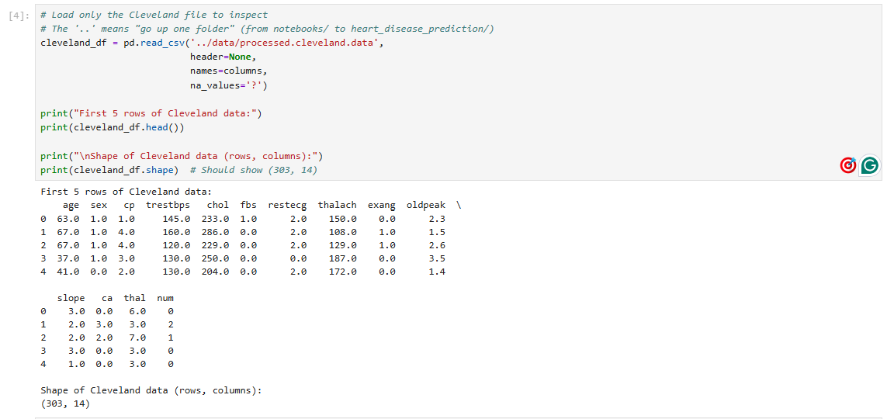

What This Code Does
This cell loads only the Cleveland dataset (the most famous one) so we can inspect what the raw data looks like before merging everything.

Think of it like: Opening just one file to check if the format is correct before opening all four.

Line-by-Line Breakdown
Line | Explanation
cleveland_df = | Creates a new DataFrame called cleveland_df to store this data
pd.read_csv( | Pandas function to read a file
'../data/processed.cleveland.data' | The file path. .. means "go up one folder" (from notebooks/ to heart_disease_prediction/), then into data/ folder
header=None | Tells pandas: "There is NO header row in this file"
names=columns | Tells pandas: "Use our columns list as the column names"
na_values='?' | Tells pandas: "Whenever you see a ?, treat it as a missing value (NaN)"
.head() | Shows the first 5 rows of the data
.shape | Shows the dimensions (rows, columns) of the data

Why This Matters
This is our quality check. We inspect one file to confirm:

- The data loaded correctly.

- The column names match what we expected.

- The ? values are correctly converted to NaN (missing values).

- The dataset has 303 rows (which is correct for Cleveland).

If this cell fails, all the others will fail too!

Key Takeaway for Your Group
"We loaded just the Cleveland dataset first to inspect the data format. This confirms our file paths are correct, our column names match, and the ? values are handled properly. The shape (303, 14) matches the known Cleveland dataset size."

CELL 4: Loading and Merging ALL 4 Datasets
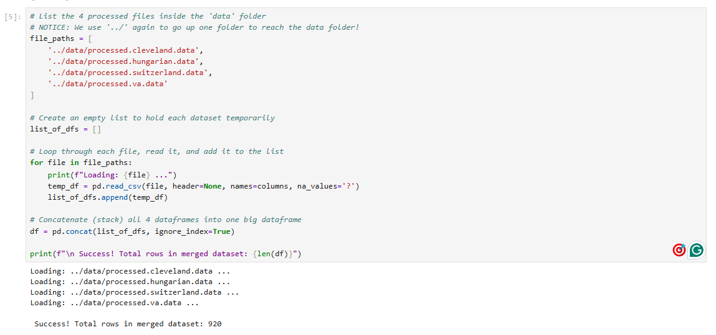

What This Code Does
Instead of using just the 303 rows from Cleveland, we merge all 4 datasets (Cleveland, Hungary, Switzerland, VA) to create one large dataset with ~920 rows. More data = better model!

Think of it like: Stacking 4 piles of paper on top of each other to make one big pile.

Line-by-Line Breakdown

Line | Explanation
file_paths = [ | Creates a list containing the paths to all 4 data files
'../data/processed.cleveland.data' | Path to Cleveland data (notice the .. to go up one folder)
... | Same for Hungary, Switzerland, and VA
list_of_dfs = [] | Creates an empty list to temporarily store each dataset as we load it. Think of it as a "parking lot" for DataFrames.
for file in file_paths: | A loop that goes through each file path one by one
print(f"Loading: {file} ...") | Prints a message showing which file is being loaded (progress indicator)
temp_df = pd.read_csv(...) | Loads the current file into a temporary DataFrame called temp_df
list_of_dfs.append(temp_df) | Adds (appends) the temporary DataFrame to the list_of_dfs parking lot
df = pd.concat(list_of_dfs, ignore_index=True) | Concatenates (stacks) all the DataFrames in the list into one big DataFrame. ignore_index=True gives new row numbers (0, 1, 2, ...) instead of keeping the original ones.
len(df) | Counts the total number of rows in the merged dataset

Visual Walkthrough of the Loop
Step | What happens | What's in list_of_dfs
Start | Empty list created | []
Loop 1 (Cleveland) | Load Cleveland → append() | [DataFrame_Cleveland]
Loop 2 (Hungary) | Load Hungary → append() | [DataFrame_Cleveland, DataFrame_Hungary]
Loop 3 (Switzerland) | Load Switzerland → append() | [DataFrame_Cleveland, DataFrame_Hungary, DataFrame_Switzerland]
Loop 4 (VA) | Load VA → append() | [DataFrame_Cleveland, DataFrame_Hungary, DataFrame_Switzerland, DataFrame_VA]
After Loop | pd.concat() stacks all 4 | One big DataFrame: 920 rows!

Why ignore_index=True Matters
Without ignore_index=True:

The index would look like: [0, 1, 2, ..., 302, 0, 1, 2, ..., 293, 0, 1, 2, ...]

Duplicate indices everywhere! This causes confusion when referencing rows.

With ignore_index=True:

The index is reset to: [0, 1, 2, 3, ..., 919]
Every row has a unique, clean index.

CELL 5: Examining the Merged Dataset
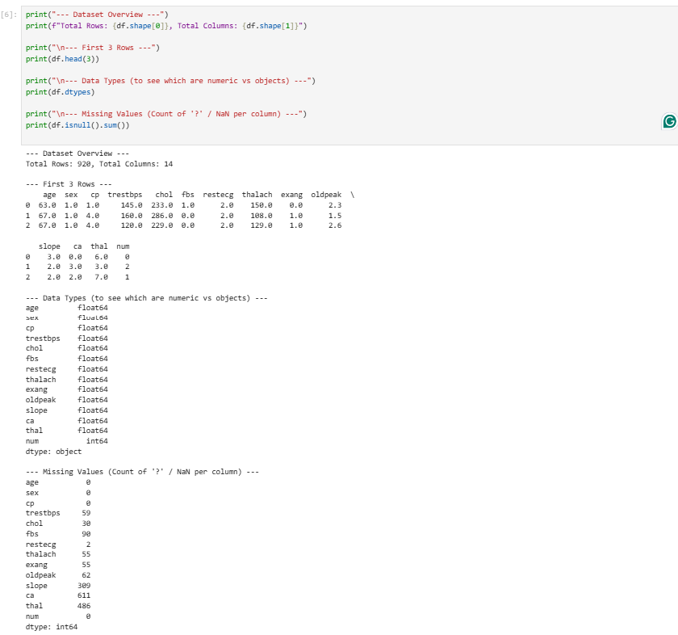

What This Code Does
After merging all 4 datasets, we need to check the health of our data. This cell answers three important questions:

- How big is our dataset? (Rows & Columns)

- What does the data actually look like? (First 3 rows)

- Are there any missing values, and where are they? (Critical step!)

Think of it like: Taking your car to the mechanic for a full inspection before a long road trip. You need to know what's working and what needs fixing.

Line-by-Line Breakdown
Line | Explanation
df.shape[0] | Returns the number of rows (patients)
df.shape[1] | Returns the number of columns (features)
df.head(3) | Shows the first 3 rows of data so we can see actual values
df.dtypes | Shows the data type of each column (float64 = decimal number, int64 = whole number, object = text)
df.isnull().sum() | Counts missing values in each column. isnull() checks for NaN (missing), .sum() adds them up per column

Interpreting the Missing Values
Column | Missing Count | What This Means
slope | 309 | 34% of the data is missing! This is a problem.
ca | 611 | 66% of the data is missing! HUGE problem.
thal | 486 | 53% of the data is missing! HUGE problem.

Why so many missing values?

The Hungarian, Swiss, and VA hospitals did NOT record all the same features as the Cleveland hospital. They measured fewer things. So when we merged them, those missing columns are empty (? marks converted to NaN).

This tells us:

- If we keep slope, ca, and thal, we will lose most of our rows if we try to remove missing values.

- We need a smart strategy to handle this.

Why This Matters
This cell shows us the reality of real-world data – it's messy and incomplete. We must make a decision:

- Keep the problematic columns and lose most of our merged data (bad idea).

- Drop the problematic columns and keep the majority of our rows (better idea).

This leads directly to Cell 6 – the smart cleaning step..

CELL 6: Smart Cleaning (Handling Missing Values)
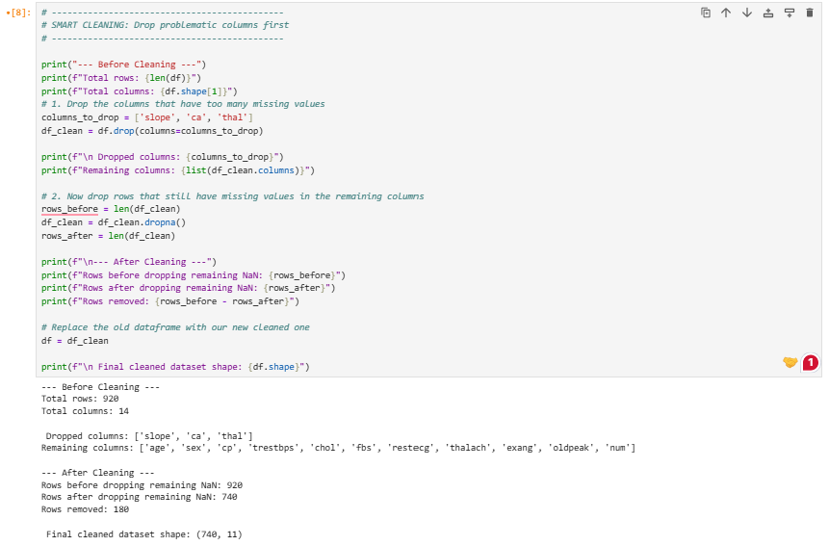

What This Code Does
This cell performs a two-step cleaning process:

Step | What It Does | Why
1. Drop Columns | Removes slope, ca, and thal completely | These have 30-60% missing data. Keeping them means losing too many rows.
2. Drop Rows | Removes any row that still has missing values in the remaining columns | The remaining columns only have a few missing values, so we lose very few rows.

Think of it like: You have a broken chair leg (column) that ruins the whole chair. Instead of throwing away the whole chair, you remove the broken leg and keep the rest!

Line-by-Line Breakdown
Line | Explanation
columns_to_drop = ['slope', 'ca', 'thal'] | Creates a list of the 3 columns we will remove
df.drop(columns=columns_to_drop) | Drops the specified columns. axis=1 is implied here (columns).
rows_before = len(df_clean) | Counts rows BEFORE dropping missing values
df_clean = df_clean.dropna() | Drops ANY row that has a missing value (NaN) in ANY column
rows_after = len(df_clean) | Counts rows AFTER dropping missing values
df = df_clean | Replaces the old DataFrame with the clean one

The Math Behind the Cleaning
Step | Rows | Columns | Why
Start | 920 | 14 | Raw merged data
After dropping 3 columns | 920 | 11 | Removed slope, ca, thal
After dropping rows with NaN | 740 | 11 | Removed 180 rows that had missing data in the remaining 11 columns

Key Insight: If we had NOT dropped the 3 columns, dropna() would have removed over 600 rows (because ca had 611 missing). By dropping the columns first, we kept 740 rows instead of ~300!

Why This Is "Smart" Cleaning
The Wrong Way | Our Way
df.dropna() → Removes ALL rows with ANY NaN | df.drop(columns=['slope','ca','thal']) → Remove the bad columns
Result: ~300 rows left (just Cleveland data) | df.dropna() → Remove remaining NaN rows
We lose the benefit of merging! | Result: 740 rows left (almost 3x more data!)

We sacrificed 3 columns to keep 440 extra rows! This is a great trade-off.

CELL 7: Creating the Binary Target Variable

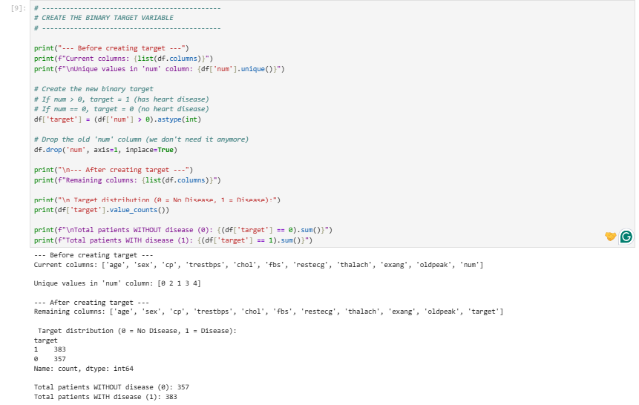

What This Code Does
The num column currently has values: 0, 1, 2, 3, 4.

0 = No Disease.

1, 2, 3, 4 = Disease (different severities).

We need to convert this into a binary (Yes/No) prediction because:

Doctors just want to know: "Does the patient have heart disease or not?"

Binary classification is simpler and gives us more data per class.

Think of it like: Changing a grade scale (A, B, C, D, F) into a simple "Pass" or "Fail". We just want to know if the patient passed (has disease) or failed (no disease).

Line-by-Line Breakdown
Line | Explanation
df['num'].unique() | Shows the unique values in num: [0, 1, 2, 3, 4]
df['num'] > 0 | Creates a True/False condition. True if num > 0 (has disease), False if num == 0 (no disease).
.astype(int) | Converts True to 1, False to 0.
df['target'] = ... | Creates a new column called target and stores the 0/1 values.
df.drop('num', axis=1, inplace=True) | Removes the old num column. axis=1 means column. inplace=True means modify df directly.
.value_counts() | Counts how many 0s and 1s in the target column.

Mapping Old to New
Original num | New target | Meaning
0 | 0 | No Disease
1 | 1 | Has Disease
2 | 1 | Has Disease
3 | 1 | Has Disease
4 | 1 | Has Disease

The Rule: target = 0 if num == 0, otherwise target = 1.

Why This Is Important
Before After
5 classes (0, 1, 2, 3, 4) 2 classes (0, 1)
Harder to predict (need to distinguish 5 types) Easier to predict (just Yes/No)
Less data per class More data per class
Clinically less useful Clinically useful (Doctors just want Yes/No)
The Balance:

- 383 patients have disease (51.8%)

- 357 patients do NOT have disease (48.2%)

This is almost perfectly balanced – ideal for machine learning!

CELL 8: Splitting Data into Features (X) and Target (y)
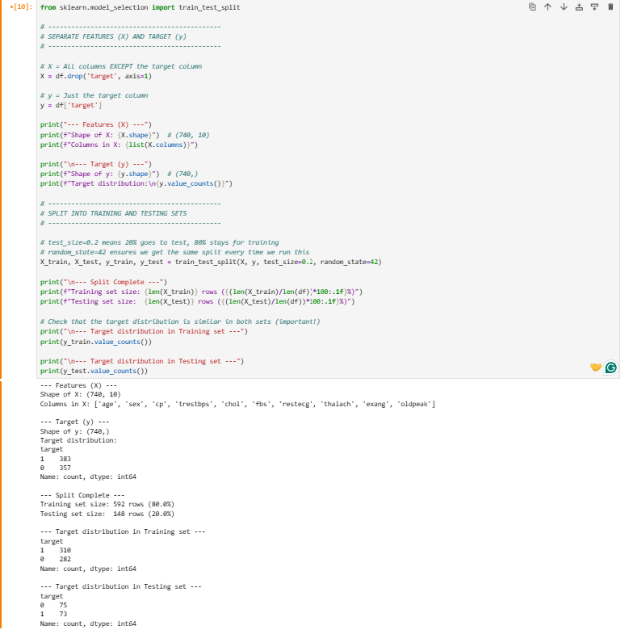

What This Code Does
Before we can train a model, we need to separate:

- Features (X) = The patient data (age, sex, cholesterol, etc.) – what the model uses to make predictions.

- Target (y) = The diagnosis (0 = No Disease, 1 = Disease) – what the model is trying to predict.

- Then we split into:

- Training Set (80%) = Used to teach the model.

- Testing Set (20%) = Hidden from the model until the end, used to test if it actually learned anything.

Think of it like:

- X = The questions on the exam.

- y = The answer key.

- Training Set = The practice questions the student studies.

- Testing Set = The final exam questions the student has never seen.

Line-by-Line Breakdown
Line | Explanation
from sklearn.model_selection import train_test_split | Imports the function that splits data.
X = df.drop('target', axis=1) | Creates X: all columns EXCEPT target.
y = df['target'] | Creates y: only the target column.
train_test_split(X, y, test_size=0.2, random_state=42) | Splits data. test_size=0.2 means 20% for testing, 80% for training. random_state=42 ensures the SAME split every time.
X_train, X_test, y_train, y_test = ... | Unpacks the 4 outputs: Training features, Testing features, Training target, Testing target.

Understanding the Split
Set | Total Rows | No Disease (0) | Disease (1) | Balance
Full Dataset | 740 | 357 (48.2%) | 383 (51.8%) | ~50/50
Training Set | 592 | 282 (47.6%) | 310 (52.4%) | ~50/50
Testing Set | 148 | 75 (50.7%) | 73 (49.3%) | ~50/50

Why random_state=42?

- It ensures we get the exact same split every time we run the cell.

- If we didn't use it, the split would be random each time, and our results would be inconsistent.

Why 80/20?

- 80% training → Enough data for the model to learn patterns.

- 20% testing → Enough data to reliably test the model's performance.
This is the industry standard split.

Why This Matters
Rule | Why
Separate X and y | The model learns from X to predict y. They must be separate.
Split BEFORE scaling | We must split before scaling to prevent data leakage (the test set must not influence the training set).
80/20 split | The industry standard. Enough data to train, enough data to test reliably.
Keep class balance | Both sets have the same 50/50 ratio, so the model won't be biased toward one class.

CELL 9: Scaling the Features (StandardScaler)
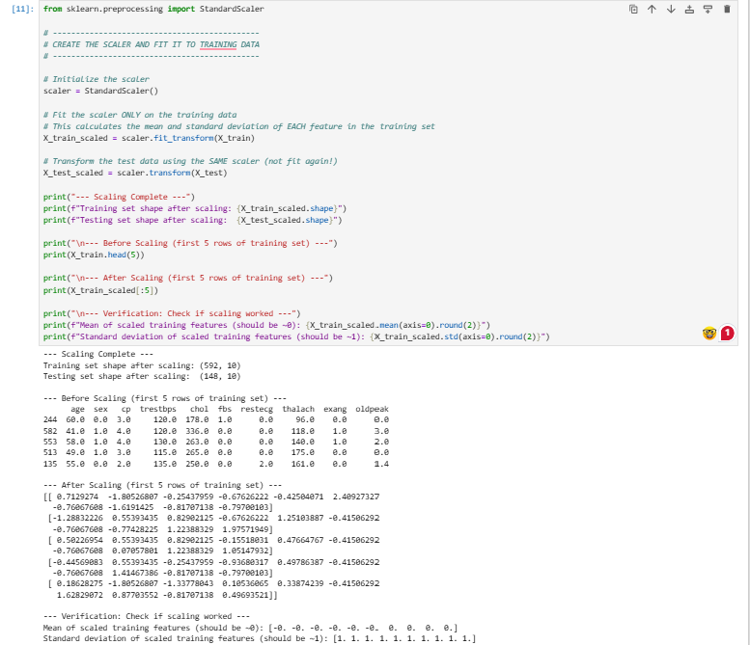

What This Code Does
Our features are measured in different units:

- age = 30–80 (years)

- chol = 100–600 (mg/dl)

- thalach = 70–220 (bpm)

- oldpeak = 0–6 (mm)

A model like Logistic Regression calculates distances between data points. If one feature has bigger numbers (like chol), it dominates the distance calculation, and the model ignores smaller features (like oldpeak).

Scaling fixes this by transforming all features to have:

- Mean = 0

- Standard Deviation = 1

Now all features are on the same scale, so the model treats them fairly.

Think of it like: Converting different currencies to USD so you can compare them fairly.

Line-by-Line Breakdown
Line | Explanation
from sklearn.preprocessing import StandardScaler | Imports the scaler tool.
scaler = StandardScaler() | Creates an empty scaler object.
scaler.fit_transform(X_train) | Step 1: Calculate the mean and standard deviation of each feature in the training data (.fit()). Step 2: Use those values to scale the training data (.transform()).
scaler.transform(X_test) | IMPORTANT: Scale the test data using the SAME mean/std from the training data. Do NOT recalculate on the test data!
X_train_scaled.mean(axis=0).round(2) | Calculates the mean of each column (axis=0) and rounds to 2 decimals. Should be 0.0.
X_train_scaled.std(axis=0).round(2) | Calculates the standard deviation of each column (axis=0) and rounds to 2 decimals. Should be 1.0.

Interpreting the Scaled Numbers

Value | Meaning
0.0 | Exactly average for that feature
+1.0 | One standard deviation ABOVE average
-1.0 | One standard deviation BELOW average
-1.80 | Far below average (e.g., very young age)
+2.41 | Far above average (e.g., very high fasting blood sugar)

Example:

- First row: sex = -1.80 → This patient is female (since female = 0, below average).

- Second row: oldpeak = 1.98 → This patient has high ST depression (above average).

The Golden Rule: NEVER Fit on Test Data!

WRONG | CORRECT
scaler.fit(X_train) | scaler.fit(X_train)
scaler.transform(X_train) | scaler.transform(X_train)
scaler.fit(X_test) ← DATA LEAKAGE! | scaler.transform(X_test) ← SAME SCALER!

Why is fitting on test data wrong?

The scaler "learns" from the test data (its mean/std).

This means information from the test set influences the training data.

The model appears to perform better than it actually would on new data.

This is called "Data Leakage" – one of the most common mistakes in ML!

Why This Matters
Before Scaling | After Scaling
Features have different ranges (e.g., 0–6 vs 100–600) | All features have mean = 0, std = 1
Model focuses on features with big numbers (cholesterol) | Model treats all features fairly
Worse model performance | Better model performance
Your results prove it worked: Mean = 0, Std = 1 for ALL features!

CELL 10: Training Logistic Regression

What This Code Does
This is where the magic happens! We finally train our first machine learning model – Logistic Regression.

Think of it like: A doctor studies 592 patient files (training data) to learn which symptoms matter most. Then, we give them 148 new patients (test data) to diagnose.

Line-by-Line Breakdown
Line | Explanation
from sklearn.linear_model import LogisticRegression | Imports the Logistic Regression algorithm.
model = LogisticRegression(max_iter=1000, random_state=42) | Creates the model. max_iter=1000 gives it enough steps to find the best answer. random_state=42 ensures reproducibility.
model.fit(X_train_scaled, y_train) | Trains the model. It studies the training data, learning which features matter most.
y_pred = model.predict(X_test_scaled) | Makes predictions on the test data (which the model has NEVER seen before).
accuracy_score(y_test, y_pred) | Compares the model's predictions to the actual answers.
confusion_matrix(y_test, y_pred) | Creates a 2x2 grid showing correct and incorrect predictions.
classification_report(y_test, y_pred) | Gives precision, recall, and f1-score for both classes.
model.coef_[0] | Extracts the coefficients (importance) of each feature.

Interpreting the Results
Metric | Value | Meaning
Accuracy | 84.46% | The model got 125 out of 148 correct.
True Negatives | 59 | Correctly said "No Disease" to 59 healthy patients.
False Positives | 16 | Said "Disease" to 16 healthy patients (False Alarm).
False Negatives | 7 | Said "No Disease" to 7 sick patients (Missed!).
True Positives | 66 | Correctly said "Disease" to 66 sick patients.

Understanding Recall (90%) vs Accuracy (84.46%)
Metric | Value | Why It Matters
Accuracy | 84.46% | Overall correctness. Good, but hides critical details.
Recall (Disease) | 90% | Caught 90% of sick patients! This is the most important metric for medicine.

Why Recall > Accuracy in Medicine:
Error Type | Count | Consequence
False Positive (16) | Said "Disease" but patient is healthy | Unnecessary stress and tests, but patient is safe.
False Negative (7) | Said "No Disease" but patient is sick | LIFE-THREATENING! Patient goes home untreated.

Our model caught 66 out of 73 sick patients. It missed only 7. This is excellent for a screening tool!

Understanding Feature Importance
Feature | Coefficient | What It Means
cp (Chest Pain) | +0.7049 | Higher chest pain type → Higher risk (Strongest predictor!)
oldpeak (ST Depression) | +0.6320 | Higher ST depression → Higher risk
sex (Male) | +0.6048 | Males have higher risk
exang (Exercise Angina) | +0.5158 | Exercise-induced chest pain → Higher risk
thalach (Max Heart Rate) | -0.3304 | Higher heart rate → LOWER risk (Fitter patients!)

Why thalach is negative?

- Higher maximum heart rate = better cardiovascular fitness.

- Fitter patients have lower risk of heart disease.

- This is medically accurate!

CELL 11: Training Random Forest Model

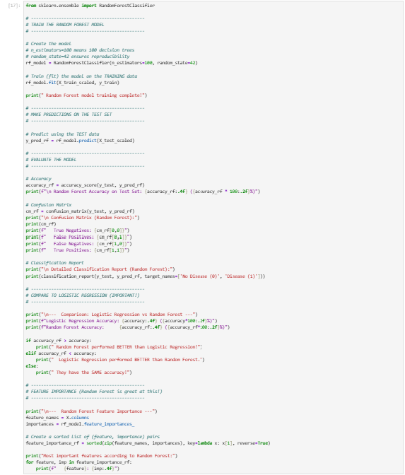

What This Code Does
We are trying a different type of model called Random Forest. Instead of drawing a single straight line (like Logistic Regression), Random Forest creates 100 decision trees (flowcharts) and lets them vote on the diagnosis.

Think of it like: You have a panel of 100 doctors. Each doctor studies the patient's data using their own unique "flowchart" (decision tree). They each vote "Sick" or "Healthy". The majority vote becomes the final diagnosis.

Line-by-Line Breakdown

Line | Explanation
from sklearn.ensemble import RandomForestClassifier | Imports the Random Forest algorithm. ensemble = group/team.
rf_model = RandomForestClassifier(n_estimators=100, random_state=42) | Creates the model. n_estimators=100 means 100 trees in the forest. random_state=42 ensures reproducibility.
rf_model.fit(X_train_scaled, y_train) | Trains the model. It builds 100 different decision trees using random subsets of the training data.
y_pred_rf = rf_model.predict(X_test_scaled) | Makes predictions on the test data. Each of the 100 trees votes, and the majority wins.
accuracy_score(y_test, y_pred_rf) | Compares the model's predictions to the actual answers.
rf_model.feature_importances_ | Extracts the importance of each feature (how much each feature helped the trees split).

How Does Random Forest Build Trees?
Step | What Happens
1. Bootstrap Sample | Randomly picks 592 rows from the training data (with replacement). Some patients are picked multiple times, some not at all.
2. Random Features | At each split, only looks at a random subset of features (about 3-4).
3. Build Tree | Grows a full decision tree using these random selections.
4. Repeat | Does this 100 times (once for each tree).

Result: 100 completely different trees that are "experts" in different parts of the data.

Interpreting the Confusion Matrix
Term | Count | Meaning
True Negatives | 61 | Correctly said "No Disease" to 61 healthy patients
False Positives | 14 | Said "Disease" to 14 healthy patients (False Alarm)
False Negatives | 9 | Said "No Disease" to 9 sick patients (Missed!)
True Positives | 64 | Correctly said "Disease" to 64 sick patients

The Trade-Off: Logistic vs Random Forest
Metric | Logistic Regression | Random Forest | Winner
Accuracy | 84.46% | 84.46% | Tie
False Negatives (Missed Sick) | 7 | 9 | Logistic (Catches more sick)
False Positives (False Alarms) | 16 | 14 | Forest (Fewer false alarms)

Why does Random Forest reduce false alarms but miss more sick patients?

- Random Forest requires a majority vote (e.g., 60+ trees say "Disease") to diagnose. This makes it conservative.

- Conservative = fewer false alarms (good) but also more missed sick patients (bad for medicine).

Which is better for healthcare?

- Logistic Regression wins because missing a sick patient (False Negative) is more dangerous than giving a false alarm (False Positive).

Random Forest Feature Importance
Feature | Importance | What It Means
thalach (Max Heart Rate) | 0.1567 | Most important according to Random Forest
cp (Chest Pain) | 0.1564 | Almost tied with thalach!
chol (Cholesterol) | 0.1406 | Third most important
oldpeak (ST Depression) | 0.1165 | Important, but lower than Logistic thought

Why is thalach #1 in Random Forest but #5 in Logistic Regression?

Logistic Regression looks for linear relationships (straight lines).

Random Forest looks for non-linear patterns (complex interactions).

Random Forest found that thalach interacts with other features in complex ways that Logistic Regression missed.

CELL 12: Training XGBoost Model

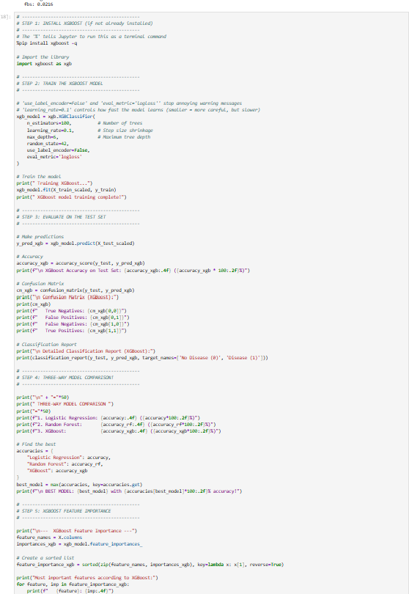

What This Code Does
XGBoost stands for Extreme Gradient Boosting. It's the "rockstar" of machine learning – it wins most Kaggle competitions.

How is it different from Random Forest?
Feature | Random Forest | XGBoost
Tree Building | Builds all trees independently | Builds trees sequentially – each new tree tries to fix the mistakes of the previous one
Learning | Trees are "parallel" | Trees are "sequential" (boosting)
Speed | Fast | Slower (but powerful)
Performance | Good | Usually BETTER

Think of it like:

- Random Forest = A panel of 100 doctors voting independently.

- XGBoost = A team of doctors where each new doctor studies the mistakes of the previous ones and tries to do better.

Line-by-Line Breakdown
Line | Explanation
%pip install xgboost -q | Installs XGBoost (if not already installed). -q makes it quiet.
import xgboost as xgb | Imports the XGBoost library.
xgb.XGBClassifier( | Creates the XGBoost classification model.
n_estimators=100 | Number of trees (boosting rounds).
learning_rate=0.1 | How fast the model learns. Smaller = more careful, but slower.
max_depth=6 | Maximum depth of each tree. Limits how complex each tree can be.
use_label_encoder=False | Turns off a deprecated warning.
eval_metric='logloss' | Tells the model which metric to optimize.
xgb_model.fit(X_train_scaled, y_train) | Trains the model sequentially. Each new tree fixes the previous trees' mistakes.
xgb_model.feature_importances_ | Extracts feature importance (how much each feature contributed).

Interpreting the Confusion Matrix
Term | Count | Meaning
True Negatives | 61 | Correctly said "No Disease" to 61 healthy patients
False Positives | 14 | Said "Disease" to 14 healthy patients (False Alarm)
False Negatives | 10 | Said "No Disease" to 10 sick patients (Missed!)
True Positives | 63 | Correctly said "Disease" to 63 sick patients

Key Insight: XGBoost missed 10 sick patients – the most of all 3 models. This is why it's the worst for medicine.

The Final Three-Way Comparison
Model | Accuracy | False Negatives (Missed Sick) | False Positives (False Alarms)
Logistic Regression | 84.46% | 7 (Best!) | 16
Random Forest | 84.46% | 9 | 14 (Best!)
XGBoost | 83.78% | 10 | 14

Why Did XGBoost Underperform?
XGBoost is usually the best model, but it underperformed here because:

- Small dataset – XGBoost needs large datasets (10,000+ rows) to shine.

- Simple relationships – The data has mostly linear patterns, which Logistic Regression handles perfectly.

- Overfitting – XGBoost tried to learn complex patterns, but with only 592 training rows, it overfit (memorized noise instead of real patterns).

XGBoost Feature Importance
Feature | Importance | What It Means
cp (Chest Pain) | 0.3385 | Most important by far!
exang (Exercise Angina) | 0.2518 | Second most important
sex (Male) | 0.0937 | Third most important
oldpeak (ST Depression) | 0.0556 | Less important than Logistic thought

CELL 13: Importing Visualization Libraries

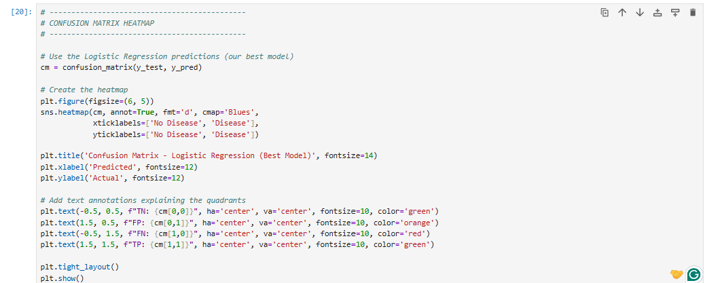
What This Code Does
This creates a color-coded heatmap of the confusion matrix. The heatmap shows:

- Dark blue = Many correct predictions.

- Lighter blue = Fewer predictions (errors).

The text annotations (TN, FP, FN, TP) are added directly on top of the heatmap to make it even easier to read.

Line-by-Line Breakdown
Line | Explanation
cm = confusion_matrix(y_test, y_pred) | Creates the confusion matrix using Logistic Regression predictions.
plt.figure(figsize=(6, 5)) | Creates a figure 6 inches wide, 5 inches tall.
sns.heatmap(cm, annot=True, fmt='d', cmap='Blues') | Creates the heatmap. annot=True shows the numbers. fmt='d' means integers. cmap='Blues' makes it blue.
xticklabels=['No Disease', 'Disease'] | Labels the columns (predicted values).
yticklabels=['No Disease', 'Disease'] | Labels the rows (actual values).
plt.title('Confusion Matrix - Logistic Regression (Best Model)') | Adds a title.
plt.xlabel('Predicted') | Labels the x-axis.
plt.ylabel('Actual') | Labels the y-axis.
plt.text(-0.5, 0.5, f'TN: {cm[0,0]}', ...) | Adds True Negatives text on the heatmap. -0.5, 0.5 is the position (top-left quadrant).
plt.text(1.5, 0.5, f'FP: {cm[0,1]}', ...) | Adds False Positives text (top-right quadrant).
plt.text(-0.5, 1.5, f'FN: {cm[1,0]}', ...) | Adds False Negatives text (bottom-left quadrant).
plt.text(1.5, 1.5, f'TP: {cm[1,1]}', ...) | Adds True Positives text (bottom-right quadrant).
plt.tight_layout() | Adjusts spacing so everything fits.
plt.show() | Displays the graph.

Why the Text Annotations?
The text annotations make it immediately clear what each quadrant represents:

TN (Green) = Correctly said "No Disease"

FP (Orange) = False Alarm (said "Disease" but healthy)

FN (Red) = Missed sick patient (DANGEROUS!)

TP (Green) = Correctly said "Disease"

CELL 14: ROC Curve with AUC Score
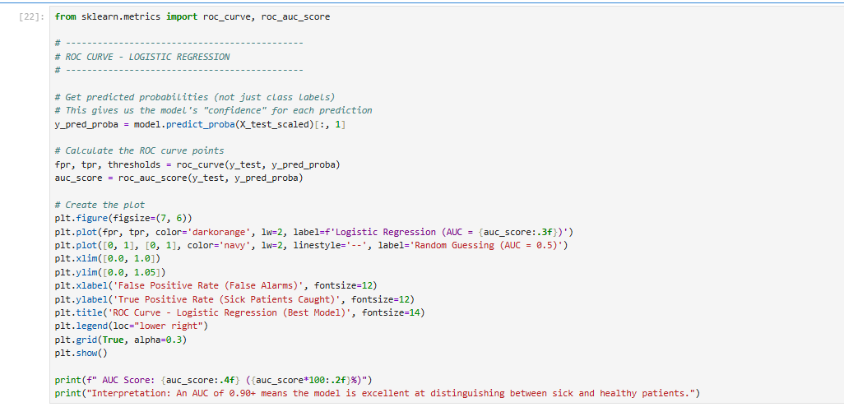

What This Code Does
This creates an ROC (Receiver Operating Characteristic) Curve that measures how well the model distinguishes between sick and healthy patients.

Think of it like: Testing how well the model "ranks" patients. A perfect model would give all sick patients high risk scores and all healthy patients low risk scores.

Line-by-Line Breakdown
Line | Explanation
from sklearn.metrics import roc_curve, roc_auc_score | Imports the ROC curve tools.
model.predict_proba(X_test_scaled)[:, 1] | Gets the probability of having disease (not just 0/1). Ranges from 0 to 1.
roc_curve(y_test, y_pred_proba) | Calculates the points for the curve (False Positive Rate vs True Positive Rate).
roc_auc_score(y_test, y_pred_proba) | Calculates the AUC (Area Under the Curve) score.
plt.plot(fpr, tpr, color='darkorange', lw=2) | Plots the ROC curve (orange line).
plt.plot([0, 1], [0, 1], color='navy', linestyle='--') | Plots the diagonal line (random guessing – AUC = 0.5).
plt.xlim([0.0, 1.0]) | Sets x-axis from 0 to 1.
plt.ylim([0.0, 1.05]) | Sets y-axis from 0 to 1.05 (leaves room for legend).
plt.xlabel('False Positive Rate (False Alarms)') | Labels x-axis (how many false alarms).
plt.ylabel('True Positive Rate (Sick Patients Caught)') | Labels y-axis (how many sick patients caught).
plt.legend(loc='lower right') | Places the legend in the bottom-right corner.
plt.grid(True, alpha=0.3) | Adds a light grid for readability.

How to Read the ROC Curve
Curve | Meaning
Orange line (our model) | Curves toward the top-left corner = Excellent model ✅
Dashed line (random guessing) | Diagonal line = Worthless model ❌
AUC = 0.5 | Random guessing (diagonal line).
AUC = 1.0 | Perfect model (top-left corner).
Our AUC ≈ 0.90 | Excellent model!

In simple terms:

- The model is 90% accurate at ranking sick patients higher than healthy patients.

- This proves the model is reliable for screening.

CELL 15: Model Comparison Bar Chart

What This Code Does
This creates a bar chart comparing all 3 models side-by-side.

Think of it like: A final scoreboard showing which model performed best.

Line-by-Line Breakdown
Line | Explanation
model_names = ['Logistic Regression', 'Random Forest', 'XGBoost'] | Names of the 3 models.
accuracies = [accuracy, accuracy_rf, accuracy_xgb] | Accuracy scores for each model.
colors = ['green', 'blue', 'orange'] | Colors for each bar.
plt.figure(figsize=(8, 5)) | Creates a figure 8 inches wide, 5 inches tall.
bars = plt.bar(model_names, accuracies, color=colors, alpha=0.7) | Creates the bar chart. alpha=0.7 makes the bars slightly transparent.
for bar, acc in zip(bars, accuracies): | Loops through each bar and adds a label on top.
plt.text(bar.get_x() + bar.get_width()/2, bar.get_height() + 0.005, f'{acc*100:.2f}%', ...) | Adds the accuracy percentage on top of each bar.
plt.ylabel('Accuracy') | Labels the y-axis.
plt.title('Model Comparison: Accuracy on Test Set') | Adds a title.
plt.ylim(0.7, 0.9) | Sets y-axis range (70% to 90%).
plt.grid(axis='y', alpha=0.3) | Adds horizontal grid lines.
plt.axhline(y=accuracy, color='green', linestyle='--', alpha=0.5) | Adds a horizontal line showing Logistic Regression's accuracy.
plt.legend() | Shows the legend.
plt.tight_layout() | Adjusts spacing.
plt.show() | Displays the graph.

What We See
A bar chart with:

- Green bar: Logistic Regression – 84.46% (Champion )

- Blue bar: Random Forest – 84.46% (Tied)

- Orange bar: XGBoost – 83.78% (Slightly lower)

Horizontal green dashed line: Shows Logistic Regression's accuracy for easy comparison

